COMPETENCY CERTIFICATION CENTRE
ASSESSOR - STANDARD OPERATING PROCEDURE

1. INTRODUCTION
The Competency Certification Centre assesses midwifery competencies through a standardized, transparent, and fair process. Assessors play a critical role in ensuring the integrity and accuracy of skill-based assessments.
Each assessor is assigned a specific Skill Station (1 out of 8), where they assess candidates' performance based on CCTV footage and record their observations using a standardized evaluation form.

2. ROLE & RESPONSIBILITIES OF EVALUATORS
- Evaluate candidates performing OSCEs (Objective Structured Clinical Examinations).
- Review CCTV footage of each candidate’s performance and complete the assigned checklist accurately.
- Only assess candidates for your assigned skill station throughout. Do not evaluate other OSCEs or switch stations.
- Maintain confidentiality and impartiality during the evaluation process.

3. EVALUATION PROCESS
This section outlines the step-by-step protocol assessors must follow during their evaluation duty.

Reporting & Setup
- Report to the Centre by 12:00 PM (or as per the schedule shared).
- Submit mobile phone and personal belongings at the reception/put them in lockers.
- Receive information regarding the designated system as well as the skill station number for which evaluation is to be conducted. Each evaluator will be mapped to a single skill station, and only assess the candidates for that particular skill station.
- The Centre Manager will share:
  - Unique Candidate IDs for the candidates to be evaluated
  - Designated system and date of assessment for which evaluation is to be done
  - Link to ODK form for assessment
- The evaluator must then proceed to the assigned desktop system.

A. Footage-Based Evaluation
- Coordinate with the Centre Manager to gain access to CCTV footage for your assigned skill station.
- Each evaluation cycle consists of a maximum of 8 candidates, each taking approximately 10-15 minutes, totaling ~2 hours.
- Some stations may contain multiple short OSCEs, while others may have a single, longer one – evaluators must still assess all candidates only for their assigned station.
- Headphones will be provided with the designated systems for evaluation.
[Placeholder - Screenshot of Footage Screen]

B. ODK Form Usage
- Use the following link to access the ODK evaluation form:
ODK Form – Evaluator Assessment
- For each candidate:
  - Enter accurate details such as Candidate ID, Station Number, and Assessment Date.
  - Mark each checklist item based on actual performance observed in the footage.
  - Ensure submission of the form after each candidate evaluation.
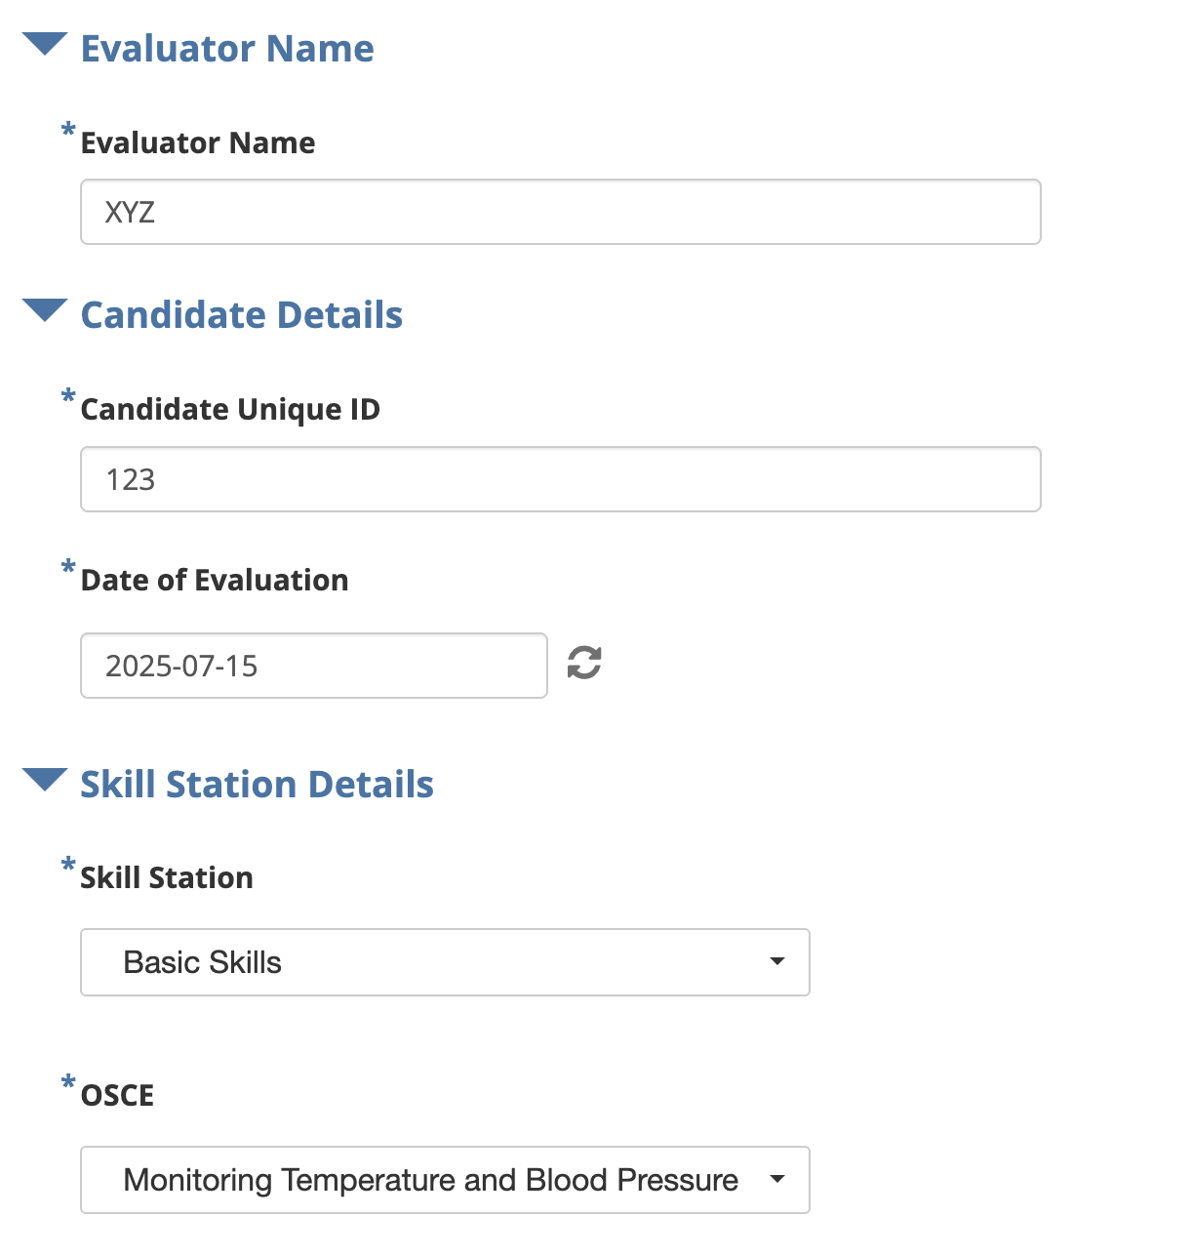
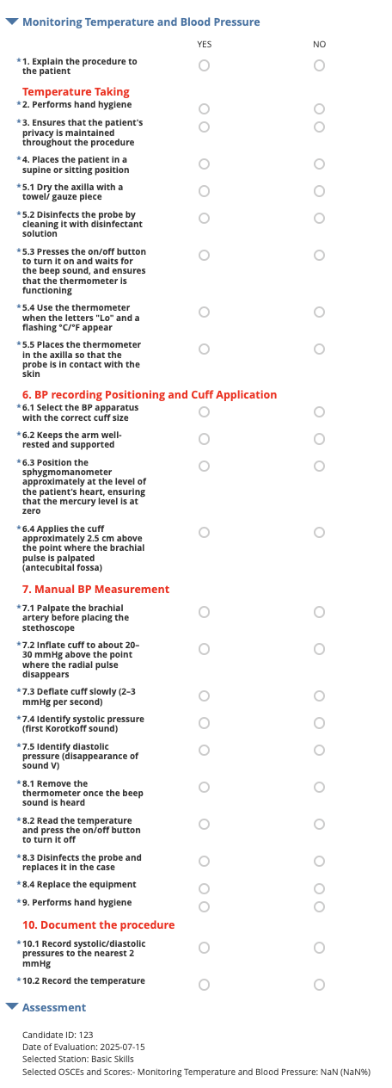

C. Timelines
- All evaluations must be completed within 72 hours of the skill assessment.
- Maintain close coordination with the Centre Manager to access footage promptly and resolve any technical issues.

4. QUALITY & COMPLIANCE
- Review footage thoroughly and avoid assumptions not backed by visual evidence.
- Avoid distractions and ensure assessments are done in a quiet, focused environment.
- Do not discuss candidate performance with others or share footage, forms, or data.

5. ESCALATIONS & SUPPORT
- If you face any issues in accessing footage, the ODK form, or need clarification on OSCEs, reach out to the Centre Manager immediately.
- In case of technical problems with the ODK tool, notify the Center Manager or IT In-Charge.

6. ONBOARDING & CERTIFICATION OF ASSESSORS
This section outlines the process for selecting, training, and certifying new assessors for the Competency Certification Centre. Only certified assessors are eligible to conduct evaluations of nursing candidates under this program.

A. Expression of Interest
- An Assessor Interest Form will be circulated periodically to invite applications from qualified individuals.
- The form will collect the following mandatory details:
  - Full Name
  - Current Designation
  - Affiliated Institution
  - Location (District and State)
  - Educational Qualifications
  - Professional Experience (Years and relevant roles)
  - Contact Number and Email Address
  - BNRC Enrollment Number
- Submissions will be reviewed by the Centre Manager and Training Coordination Team to verify eligibility and suitability.

B. Training of Prospective Assessors
- Shortlisted candidates will be required to undergo a mandatory Assessor Training Program, facilitated by a team of nursing experts.
- The training will cover:
  - Clinical overview and procedures of all 8 skill stations
  - Understanding of performance benchmarks and clinical checklists
  - Use of CCTV footage for evaluation
  - Hands-on demo of the ODK-based checklist form
  - Common errors and how to evaluate borderline performance
  - Guidelines on ethical and fair evaluation
- The training will be conducted in offline mode at the Certification Centre, unless otherwise specified. Attendance in all sessions is mandatory.
- Training sessions will include:
  - Lectures and demonstrations
  - Observation of sample candidate videos
  - Practice evaluation using mock ODK forms
  - Q&A and debrief sessions with the expert team
- All training activities will be coordinated by the Centre Manager, in collaboration with the designated clinical faculty.

C. Certification Process
- Upon completion of training, each prospective assessor must appear for a two-part Certification Test:
Part 1: Computer-Based Test (CBT)
  - 90-minute test with multiple-choice questions covering midwifery procedures, clinical judgement, and evaluation ethics
  - Minimum qualifying score: 70%
Part 2: Skill-Based Assessment
This component tests both practical clinical ability and evaluation accuracy.
A. Performance of OSCEs
  - Each prospective assessor must personally perform all clinical OSCEs selected at the 8 standard stations.
  - This performance will be:
    - Conducted under simulated conditions
    - Observed and scored by senior clinical trainers
    - Evaluated using the same standardized checklists used for candidate assessment
  - The goal is to ensure assessors understand the procedures from a practitioner’s perspective and demonstrate clinical competence.
B. Evaluation of Mock Candidates
- In addition to performing OSCEs, the assessor will evaluate recorded footage of 2 mock candidates using the ODK tool.
- Assessment will be judged based on:
  - Accuracy of marking
  - Completeness of observations
  - Adherence to checklist items and evaluation protocol
- Senior trainers will cross-verify submitted evaluations against the master key.
- To be certified, the assessor must pass both components.
- Certified assessors will receive:
  - A digital certificate with a unique assessor ID
  - Formal communication from the Centre
  - Their name entered into the official Assessor Registry
- The certification remains valid for 1 year, post which refresher training may be mandated.

D. Documentation & Record-Keeping
- All interest forms, training attendance, test scores, and evaluation sheets will be securely maintained by the Centre Manager.
- Certification records will be shared with the programme implementation team and retained for audit purposes.

E. Reassessment Protocol
- Candidates who fail either the CBT or Skill-Based Assessment will be eligible for one reassessment attempt after attending a refresher session.
- Those failing the reassessment will not be certified and must re-apply through the interest form in the next cycle.

F. Ethical Conduct and Compliance
- All assessors must sign a code of conduct and consent form before being issued certification.
- Certification may be revoked at any time in case of:
  - Proven bias, misconduct, or data breach
  - Repeated poor-quality evaluations
  - Non-compliance with standard protocols

